PIZZA SALES QUERY

1)Total Revenue

SELECT sum(total_price) AS TOTAL_REVENUE FROM pizzadb.pizza_sales_excel_file;

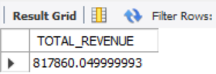

2) Avg_Order_value

SELECT SUM(total_price) / count(distinct order_id) AS Avg_Order_value FROM pizzadb.pizza_sales_excel_file;

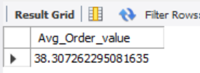

3) Total_Pizza_Sold

SELECT SUM(quantity) AS Total_Pizza_Sold FROM pizzadb.pizza_sales_excel_file;

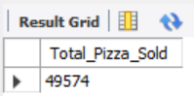

4) Total_Orders

SELECT COUNT(distinct order_id) AS Total_Orders FROM pizzadb.pizza_sales_excel_file;

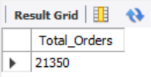

5) Average_Pizza_Per_order

SELECT SUM(quantity) / COUNT(distinct order_id) AS Average_Pizza_Per_order FROM pizzadb.pizza_sales_excel_file;

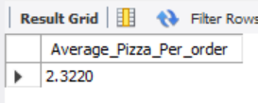

6) Hourly Trend for Total Pizza sold

SELECT extract(HOUR from order_time) AS Order_hours, sum(quantity) AS Total_Pizzas_Sold

FROM pizzadb.pizza_sales_excel_file

GROUP BY Order_hours

ORDER BY Order_hours;

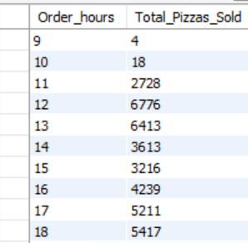

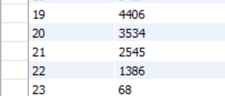

7) Weekly Trend for Total Orders

SELECT extract(week from order_date) as week_number,year(order_date) as order_year, count(distinct order_id) as Total_orders

FROM pizzadb.pizza_sales_excel_file

GROUP BY week_number , order_year

ORDER BY week_number , order_year ;

8) Percentage of pizza sales by pizza category

SELECT pizza_category, sum(total_price)*100/(SELECT sum(total_price) FROM pizzadb.pizza_sales_excel_file) AS PCT

FROM pizzadb.pizza_sales_excel_file

GROUP BY pizza_category;

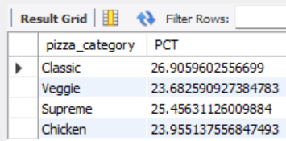

9) Percentage of sales by pizza size

SELECT pizza_size,cast(sum(total_price) AS DECIMAL(10,2)) as Total_Sales, cast(sum(total_price)*100/(SELECT sum(total_price) FROM pizzadb.pizza_sales_excel_file) AS DECIMAL(10,2)) AS PCT FROM pizzadb.pizza_sales_excel_file

GROUP BY pizza_size

order by PCT desc;

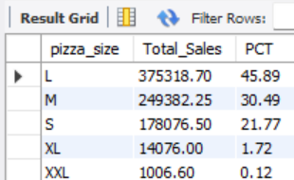

10) Top 5 Best Sellers by Revenue,Total Quantity,Total Orders

SELECT pizza_name,sum(total_price) as Total_Revenue

FROM pizzadb.pizza_sales_excel_file

GROUP BY pizza_name

order by Total_Revenue desc

Limit 5;

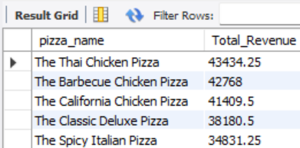

SELECT pizza_name,sum(quantity) as Total_quantity

FROM pizzadb.pizza_sales_excel_file

GROUP BY pizza_name

order by Total_quantity desc

Limit 5;

